**DNA methylation as a possible causal mechanism linking childhood adversity and health: Results from two-sample mendelian randomization study.**

**Figure S1.** A schematic overview of the two-sample mendelian randomization design.

**Figure S2.** Effect estimates across DNAm loci and health outcomes for primary analyses.

**Figure S3.** Effect estimates across DNAm loci and health outcomes for triangulation analyses.

**Figure S4.** Leave-one-out results (beta and 95% confidence intervals) for suggestive DNAm loci with >2 SNPs as instrumental variables.

**Please note that the following supplementary materials can be found in Appendix S2:**

**Table S1.** STROBE checklist for MR studies

**Table S2.** Annotated DNAm loci

**Table S3.** Instrumental variables

**Table S4.** Number of DNAm loci analyzed for each health outcome

**Table S5.** Associations between DNAm loci and health outcomes (full results primary analyses)

**Table S6.** Associations between DNAm loci and health outcomes (full results replication analyses)

**Table S7.** Follow-up of DNAm loci with multiple SNPs, using Wald ratio's on all single SNP

**Table S8.** MR Egger results to test for directional horizontal pleiotropy (intercept test) for top and nominal DNAm loci

**Table S9.** Test for heterogeneity for top and nominal DNAm loci

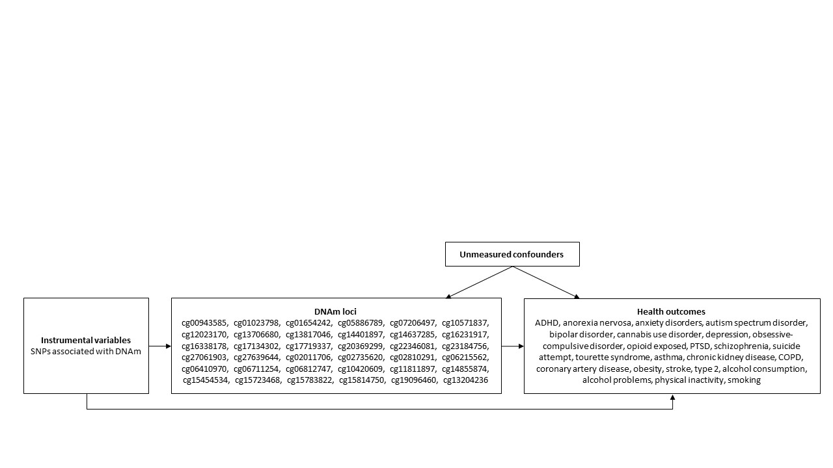

**Figure S1. A schematic overview of the two-sample mendelian randomization design.**

**Figure S2. Effect estimates across DNAm loci and health outcomes for primary analyses.** ADHD = attention-deficit/hyperactivity disorder; PTSD = Post-traumatic stress disorder; COPD = chronic obstructive pulmonary disease. The direction of the effect estimate was transformed according to the directionality between childhood adversity and DNAm, meaning that positive estimates reflect a risk increasing role of DNAm (red), and negative estimates reflect a risk suppressing effect of DNAm (blue). The x-axis includes each loci assessed; the y-axis includes all of the mental health outcomes tested. The order of the x axis and y axis is based on hierarchical ordering: loci and health outcomes were clustered based on the similarity of their associations with each set of outcome types (mental, physical, health risk). DNAm loci with SNPs that were not reported directly in the health outcome studies are shown in dark gray.

**Figure S3. Effect estimates across DNAm loci and health outcomes for triangulation analyses.** ADHD = attention-deficit/hyperactivity disorder; PTSD = Post-traumatic stress disorder; COPD = chronic obstructive pulmonary disease. The direction of the effect estimate was transformed according to the directionality between childhood adversity and DNAm, meaning that positive estimates reflect a risk increasing role of DNAm (red), and negative estimates reflect a risk suppressing effect of DNAm (blue). The x-axis includes each loci assessed; the y-axis includes all of the mental health outcomes tested. The order of the x axis and y axis is based on hierarchical ordering: loci and health outcomes were clustered based on the similarity of their associations with each set of outcome types (mental, physical, health risk). DNAm loci with SNPs that were not reported directly in the health outcome studies are shown in dark gray.

**Figure S4. Leave-one-out results (beta and 95% confidence intervals) for suggestive DNAm loci with >2 SNPs as instrumental variables.**